Images: Part 1 | Examples

Screen reading software demo
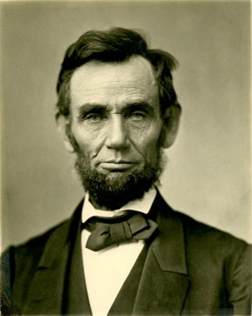
As the sixteenth President of the United States, Abraham Lincoln served as the Commander-in-Chief during the Civil War. He was assassinated five days after the surrender of the Confederate army.

Example 1


Example 2
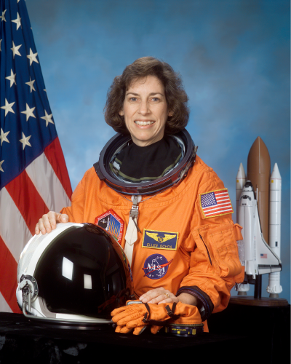
As the first Hispanic woman to go to space, and, later, the first Hispanic director of the Johnson Space Center, Ellen Ochoa is widely regarded as a role model.
What would be equivalent and effective Alt Text for this image?
- “Image of Ellen Ochoa, Astronaut”
- "Astronaut Ellen Ochoa"
- “Ellen Ochoa, the first Hispanic woman to go into space.”

Example 3
Ellen Ochoa, Astronaut
As the first Hispanic woman to go to space, and, later, the first Hispanic director of the Johnson Space Center, Ellen Ochoa is widely regarded as a role model.
What would be equivalent and effective Alt Text for this image?
- An Alt Text value of “Image”
- An Alt Text value of "Astronaut Ellen Ochoa"
- None––equivalent alternative text is already provided.

Example 4
Ellen Ochoa, Astronaut
As the first Hispanic woman to go to space, and, later, the first Hispanic director of the Johnson Space Center, Ellen Ochoa is widely regarded as a role model.
What would be the best alternative text for the content and function of this image?
- Alt Text of “Astronaut Ellen Ochoa”
- Alt Text of “Wikipedia entry for Ellen Ochoa”
- Mark this image as decorative.

